Heartstrings Press
49 Starview Place, Lancaster, VA 22503

Meet this unique mother / daughter-in-law / daughter team
Authors of Grandloving: Making Memories with Your Grandchildren, 5thed

Sue Johnson  Sue Johnson is the founder of Gramma's Graphics, Inc., Heartstrings Press, and the online resource, www.grandloving.com. A mother of three, grandmother of six and an honorary mother of eight exchange students, Sue is passionate about family.  When her initial Grandloving query to 150 of their friends snowballed into 350 responses, Sue knew she'd struck a chord with enthusiastic grandparents. As a long-distance grandmother, she uses ideas from her years as a teacher to enliven communications with her grandchildren.  Known as a contemporary grandparenting expert, Sue serves as a judge for the Mom's Choice Award. She, with her husband of 49 years, lives on the Northern Neck of Virginia. | 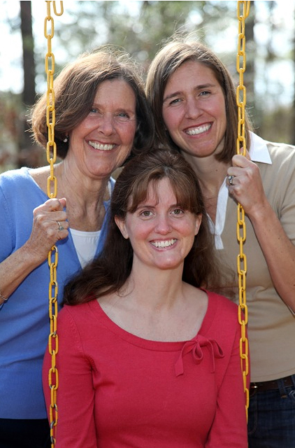

Julie Carlson
Julie Carlson, Sue’s daughter-in-law, also a former teacher, is a happily married mother of three sons (ages 16, 12 and six) who lives and works near Philadelphia. She is an honors graduate of Yale (1988) and an alumna of the Radcliffe Publishing Course (1988). An editor since 1989, Julie freelances for the university presses at Harvard and Yale. Julie's developmental editing and writing have shaped many high-profile nonfiction manuscripts, many of which have garnered praise from major review media such as the New York Times and Washington Post.

Elizabeth Bower
Elizabeth Bower, Sue's daughter, lives with her husband and two year old son in Nashville. She taught elementary grades for 11 years and progressed to mentoring student teachers at Northwestern University and teaching prospective teachers at Loyola University Chicago. Passionate about education, Bower began her studies at Connecticut College. She spent a year at the University of Edinburgh in Scotland and graduated with a master’s degree from the Harvard Graduate School of Education. Elizabeth is experiencing long distance Grandloving first hand as their son has grandparents in Singapore and England. As the newest member of the team, she brings fresh insights to the group. Elizabeth also serves as a distinguished judge for the Mom’s Choice Award.

Committed to uniting the generations, Sue, Julie and Elizabeth have authored many articles and features for grandparenting and parenting publications and Web sites. They are available for interviews, articles and presentations.
Grandloving 5thed by Johnson, Carlson & Bower
Pub Date: April 2010 • ISBN: 978-0-9675349-7-8
Published by Heartstring Press • 804-462-0884
Distributed by IPG • 800-888-4741

For additional information, visit www.grandloving.com or contact publicist:
Kate Bandos, KSB Promotions, 800-304-3269, kate@KSBPromotions.com

